Austrian Alpine Club (UK)

Stubaier Höhenweg Tour, Stubaital, Tyrol
The Stubaier Höhenweg is a classic tour around the head of the Stubaital. This route provides opportunities to deviate off the path and ascend some of the peaks in the area, including Habicht, Wilder Freiger and Sonklar Spitze and Zuckerhütl  Jul to early September  This tour should not be confused with the more popular long distance multi-day hut to hut Stubai Höhenweg Runde Tour. | 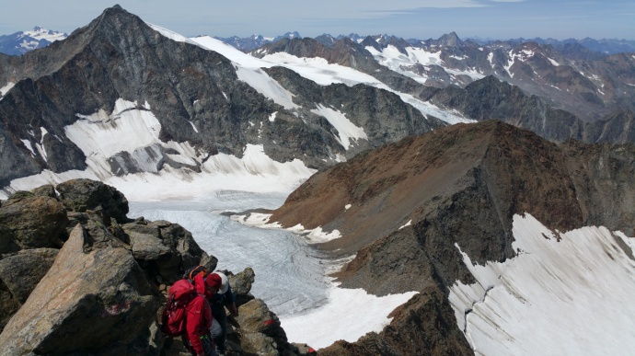

Overview | The tour starts from Neustift im Stubaital with a day training and acclimatising at the Innsbrucker Hut. The route is a clockwise one, taking an extra day to climb Sonklar Spitze from the Müller Hut. One advantage of this route is that if you need to descend into the valley, this can be accomplished in just a few hours from each hut (except Mueller Hut).
Grade | This route is a significant alpine journey across mountainous terrain. The Höhenweg itself is protected by maintained cables where necessary. The climbs, although following established routes, are not maintained so teamwork is needed for protection. For this reason, participants should be comfortable with trad climbing at UIAA Grade III/ PD or British V Diff. Recent experience of ‘moving together’ with a rope, on both rock and ice, is also required.
Maps | AV map 31/1 Stubaier Alpen, Hochstubai, 1:25,000  Mayr Stubaital sheet 18, 1:35,000  Kompass Wanderkarte sheet 83 Stubai Alpen 1:50,000
Guide books | Trekking in the Stubai Alps, by Allan Hartley: Cicerone Press

Route Summary:

Day | Route and Activities | Accommodation/Hut  OB = online booking | Total time
1 | Overnight in Neustift (993m). | B&B in Neustift
2 | Gondelbahn Neustift to Bergrestaurant Agrar (1794m).  Follow Panoramaweg, possibly via the Elferspitze (2505m), to Karalm (1747m) then to Innsbrucker Hütte.  Alternatively make use of the minibus shuttle taxi service from Neder direct to Karalm. | Innsbrucker Hütte (2369m)  ÖAV | 5 hours
3 | Training and acclimatisation around Innsbrucker Hütte, with possible rope practice and ascent of Habicht (3277m) | Innsbrucker Hütte (2369m) | 5 hours
4 | To Bremer Hütte via Pramarnspitze (2511m) – some fixed cables. | Bremer Hütte (2411m)  DAV - OB | 7-8 hours
5 | To Nürnberger Hütte via Simmingjöchl (2754m) | Nürnberger Hütte (2278m)  DAV - OB | 3 hours
6 | To Müllerhütte via Seescharte (2762m) and Wilder Freiger (3418m). Roped movement and glacier travel. | Müllerhütte (3145m)  Province Bozen | 6 hours
7 | At Müllerhütte: ascent of Sonklar Spitze 3450m | Müllerhütte (3145m)  Province Bozen | 4 hours
8 | To Hildesheimer Hütte via Wilder Pfaff and Zuckerhütl (3507m) and Sulzenauferner. Roped movement and glacier travel. | Hildesheimer Hütte 2900m  DAV | 7 hours
9 | Hildesheimer Hütte to Dresdner Hut via Eisjoch 3133m; cable car to Dresdner Hütte. Afternoon Klettersteig on the Egesengrat. | Dresdner Hütte (2308m)  DAV | 3 hours
10 | Via Egesengrat (2631m) to Mutterbergalm (1725m).  Bus back to Neustift (or Innsbruck) for B&B. | B&B in Neustift | 4 hours

Huts
Innsbrucker Hütte www.alpenverein.at/innsbruckerhuette/
Bremer Hütte www.alpenverein.at/huetten/index.php?huette_nr=0519
Nürnberger Hütte www.alpenverein.at/huetten/index.php?huette_nr=0608
Müllerhütte www.alpenverein.at/huetten/index.php?huette_nr=1210
Sulzenauhütte www.alpenverein.at/huetten/index.php?huette_nr=0642
Dresdner Hütte www.alpenverein.at/huetten/index.php?huette_nr=0527
Hildesheimer Hütte www.hildesheimerhuette.at

Updated and edited by AH/ July 2020

