Austrian Alpine Club (UK)

Rätikon Tour, Vorarlberg
The Rätikon mountain range is at the western end of Austria, north of the border with Switzerland. This tour is glacier-free and starts and ends in Bludenz.  July to early September | 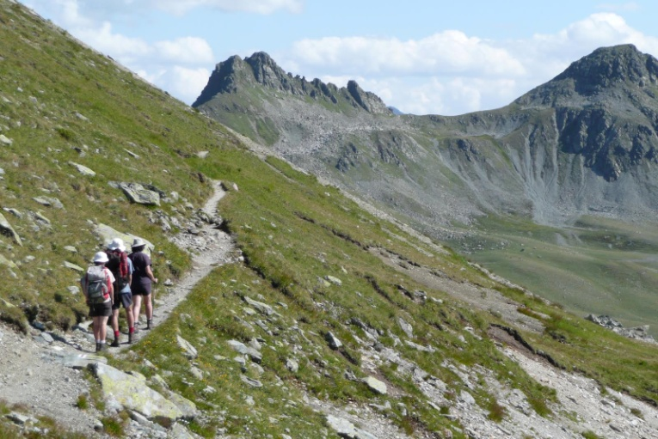

Overview | This is a one week hut-to-hut tour in a limestone area with mountains up to almost 3000m. The route in general heads east, keeping north of the mountainous Swiss/Austrian border, crossing several passes.  The route itself does not reach any summits, but there is the option of climbing three separate summits.
Grade | The height gain varies throughout the week. By UK hill walking standards, none of the days are particularly tough. However, it is usually above 1700m, and the passes are all above 2300m.  Much of the route is on paths, involving a variety of challenging terrain: extensive boulder fields, steep loose ground, rock sections, (up, down, traverse) where hands need to be used, very exposed sections where even a simple slip would be very serious; and maybe sections fitted with wire ropes. In Austria, such steelwork is usually in good condition, but not always.  The route should be largely snow free but if the tour is done early in the season, there may still be some winter snow.
Maps | Kompass 032 - Montafon, 1:25,000.
Guidebooks | Walking in Austria by Kev Reynolds, Cicerone Press  Trekking in the Alps [compilation of tours] Cicerone press  Mountain Walking in Austria by Cecil Davies, Cicerone 1986, out of print but still a good indicative guide, available on Amazon

Route Summary:

Day | Route and Activities | Accommodation/Hut | Total ascent
1 | From Bludenz by bus to head of Brandnertal (1566m); walk up to Totalphütte (cable car available part way).  The Totalp Hut was destroyed by avalanche in 2019 but re-opened in summer 2020. | Totalphütte (2381m)  ÖAV = OB | 815m+
2 | To Lindauer Hütte via Verajoch (2330m) and Öfapass (2291m)  Optional peak: Schesaplana (2965m) See note below. | Lindauer Hütte (1744m) | 500m+
3 | A rest day or optional peak, Drei Türme (2722m) | Lindauer Hütte (1744m)  DAV - OB | 980m+
4 | To Tilisunahütte via Schwarze Scharte (2330m)  Optional peak: Sulzfluh (2818m) | Tilisunahütte (2211m)  ÖAV = OB | 650m+
5 | To Gargellen (1423m) via Sarotlajoch (2389m) | B&B in Gargellan (1423m) | 300m^
6 | To Tübinger Hütte via Vergaldner Joch (2515m) | Tübinger Hütte (2191m)  DAV= OB | 1090m+
7 | To Vermuntstausee (1743m) (NW of Bielerhöhe) via Hochmadererjoch (2505m), then bus to Bludenz. | Bludenz | 320m+

There are 3 peaks that could be climbed during the tour.

Ascent of Schesaplana 2965m
At almost 3000m, this once previous snow peak is now relatively snow free with most of the winter snow having gone by mid June, however the upper top third of the mountains provides a good scrambling experience and, as Kev Reynolds writes, for those with scrambling experience and a good head for heights, the ascent of the lofty Schesaplana is hard to resist. In truth it is not a particular difficult ascent by the waymarked route but caution is needed. Allow 4hr for the ascent
The Drei Türme (Three Towers) are more serious rock peaks that do involve more scrambling.

Huts
Totalphütte www.alpenverein.at/totalphuette/
Lindauer Hütte www.alpenverein.at/huetten/index.php?huette_nr=0593
Tilisunahütte www.alpenverein.at/tilisunahuette/
Tübinger Hütte www.alpenverein.at/huetten/index.php?huette_nr=0646

Updated/revised by AH July 2020

