Austrian Alpine Club (UK)

Olperer Runde, Zillertal, Tyrol
This tour explores the western edge of the Zillertal Alps progressing in a counter clockwise direction around the Olperer 3476m, third highest peak in the Zillertal. The tour starts in Mayrhofen, then follows a glacier free route to the Olpererhütte, Friesenberg Haus, Tuxer Joch Haus, Geraer Hütte and back to Schlegeis and Mayrhofen.  July to early September  The Olperer Hütte looking towards the Süd Tirol across the Schlegeis reservoir towards the peaks of the Hochfeiler (right) and Groꞵer Möseler (left): Allan Hartley | 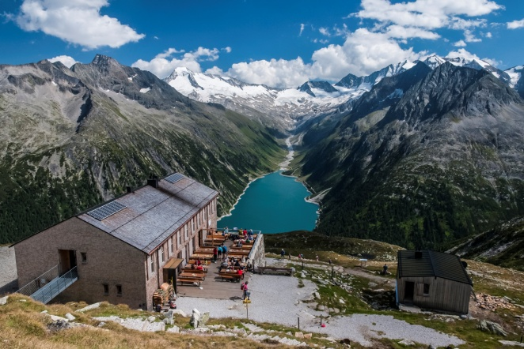

Overview | This tour proves that alpine walking can be interesting, and scenically stunning. A rucksack, a decent pair of boots and personal gear are all that are required.
Grade | Overall the tour is relatively straight forward with little technical difficulty. In terms of physical difficulty the tour is a moderately strenuous tour with most days being around six hours duration. Remember the times given are the times spent moving without any rest stops, so for overall journey time you can add a minimum of one hour.
Maps | Sheet 35/1; Zillertal Alpen. Westliches 1:25’000  Kompass Wanderkarte; Sheet 37 Zillertaler Alpen; Tuxer Alpen
Guidebooks | Trekking in the Zillertal Alps by Allan Hartley.
Websites | https://www.naturpark-zillertal.at/en/nature-park-experience/trekking-the-berliner-hoehenweg.html  www.mayrhofen.at

Route Summary:

Day | Route and Activities | Accommodation/Hut  OB = online booking | Height gain/Time
1 | Overnight in Mayrhofen | Mayrhofen
2 | Bus to Schlegeis (1782m), then follow the Panoramaweg to the Olpererhütte. | Olpererhütte (2389m)  DAV - OB | 590m+  3 hours
3 | To Friesenberghaus.  Afternoon ascent of Peterskopfl (2677m) | Friesenberghaus (2477m)  DAV - OB | 245m+  3 hours
4 | To Tuxerjoch Haus via the Friesenbergscharte (2910m) and Spannagelhaus (2531m). | Tuxerjoch Haus (2313m)  private | 750m+  6 hours
5 | To the Geraer Hütte via the Frauenwand (2537m) and Kleesgruben Scharte (2498m). | Geraer Hütte (2326m)  DAV - OB | 750m+  6 hours
6 | Via the Alpeiner Scharte (2959m) and continue to Pfitscherjoch-Haus . | Pfitscherjoch-Haus (2276m)  private | 633m+  6 hours
7 | Return to Schlegeis and bus back to Mayrhofen | Mayrhofen

See next page for huts

Huts
Olpererhütte www.alpenverein.at/huetten/index.php?huette_nr=0611
Friesenberghaus www.alpenverein.at/huetten/index.php?huette_nr=0538
Tuxerjoch Haus (private) www.tuxerjochhaus.at/
Geraer Hütte www.alpenverein.at/huetten/index.php?huette_nr=0547
Pfitscherjoch-Haus (private) www.pfitscherjochhaus.com

Updated/revised AH July 2020

