Austrian Alpine Club (UK)

Karnische Höhenweg - East Tyrol and Carinthia
This tour starts and ends in Lienz. This tour shows history in terms of relics from WWI and wonderful karst scenery of limestone and dolomite.  End June - September | 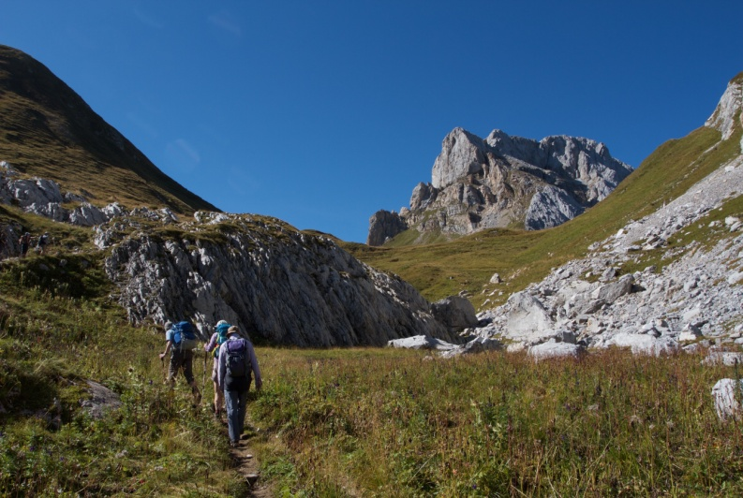

Overview | This is a ten day hut-to-hut tour along the Karnische Höhenweg (Der Friedens Weg) in the Ost Tirol, a ridge with mountains up to 2,700m. In general terms the route follows a long ridge forming the border between Austria and Italy.  This plan allows for two nights at two huts for rest days or exploring peaks.
Grade | In terms of physical difficulty the Höhenweg is a moderately strenuous tour with most days being around six hours duration. It should be well within the capability of anyone who can walk on Scafell Pike and is ideal for those new to Austrian hut tours. One day involves a challenging walk of at least 10 hours over difficult terrain.  The tour also traverses a number of ridge summits and several high passes which are not difficult. It is usually above 2100m, and the passes are all above 2700m so there may be (initially at least) some effects of altitude.  Much of the route is on paths. However these paths may well involve a variety of challenging terrain: extensive boulder fields, steep loose ground, rock sections, (up, down, traverse) where hands need to be used, very exposed sections where even a simple slip would be very serious; and some sections fitted with wire ropes. In Austria, such steelwork is usually in good condition, but not always.
Maps | Kompass Wanderkarte sheet 47 Lienzer Dolomiten & Lesachtal
Websites | http://www.geopark-karnische-alpen.at/Startseite.1447.0.html

Route Summary:

Day | Route and Activities | Accommodation/Hut  OB = online booking | Height Gain
1 | Travel to Sillian and then taxi to Leckfeldalm (1925m). Then walk up to Sillianer Hütte. | Sillianer Hütte (2447m)  ÖAV | 500m+
2 | Walk up to Hochgruben (2538m) and then past Eisenreich (2665m) to Obstansersee-Hütte. Plenty of time for sightseeing the WW1 monuments and exploring path variants. | Obstansersee-Hütte (2304m)  ÖAV - OB | 500m+  600m-
3 | Walk to Kinigat (2664m) with break at Filmoor Standschűtzhűtte. Walk to Porzehűtte either via Obere Stuckensee (2032m) or Windkarleck. | Porzehűtte (1942m)  ÖAV - OB | 400m+  700m-
4 | Long 10 hour hike via Bärenbadeck (2430m) and Torkar Spitze (2486m) to Hochweißsteinhaus. | Hochweißsteinhaus (1868m)  ÖAV | 1850m+  1850m-
5 | A rest day or a chance to explore Monte Peralba (2490m) | Hochweißsteinhaus (1868m)  ÖAV | 600m+  600m-
6 | Continue to Fleons Valley, Italy, via the Öfner Joch (2011m) then via Niedergailer Joch (1971m) to Wolayerseehütte. | Wolayerseehűtte (1967m)  ÖAV - OB | 900m+  900m-
7 | A rest day or explore Rauchkofel (2460m), Hohe Warte (2780m), and the geological wonders around the lake. | Wolayerseehűtte  (1967m) | 600m+  600m-
8 | Travel to Valentin Alm | Valentinalm  private | 700m+  700m-
9 | Descend to Plőcken and taxi back to Lienz

Huts
Sillianer Hütte http://www.alpenverein.at/sillianerhuette/
Obstansersee-Hütte http://www.alpenverein.at/obstanserseehuette/
Porzehűtte http://www.alpenverein.at/porzehuette/
Hochweißsteinhaus http://www.alpenverein.at/hochweisssteinhaus/
Wolayerseehűtte http://www.alpenverein.at/wolayerseehuette/
Valentinalm www.valentinalm.at/ (private)

